February 2, 2025                                                      FOR IMMEDIATE RELEASE

Gaylyn Williams

[gaylynw@gmail.com](mailto:gaylynw@gmail.com), 719-201-7181, [www.RelationshipResources.org](http://www.RelationshipResources.org)

[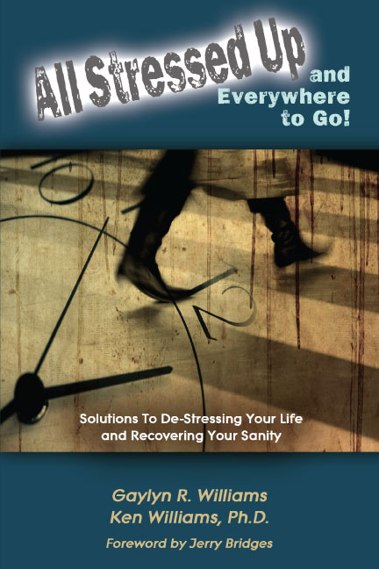](https://relationshipresources.org/stress-management-tips/)**Biblical Solution to Stress Frees Americans ‘At Last!’**

COLORADO SPRINGS, CO – A survey[1] found that Americans’ average stress levels are a five out of 10 (10 being the highest); 24% said their average stress is between 8 and 10. 47% said they wish they had help to manage their stress. Did you know stress causes many side effects, including mental health issues and chronic diseases? Where do you fit in these statistics, and how do you manage your stress?

Gaylyn Williams and her father, Ken Williams, Ph.D., wrote a practical book on managing stress, [*All Stressed Up and Everywhere to Go*](https://relationshipresources.org/stress-management-tips/), and trained a worldwide network of over 50,000 people empowering them to manage their stress effectively now and in the future. What is their secret? Proven biblical principles! The book and training on stress, updated in 2025, guide individuals and groups through easy-to-apply skills to lower stress levels. The powerful strategies can last a lifetime, enabling people to gain greater freedom from life’s ups and downs.

**Click the cover to learn more.**

**Reviews from Respected Ministry Leaders:**

***Gary Wilkerson, President of World Challenge*, said, “**I recommend you read this important book. This book’s biblical solutions and personal truths can free your heart, mind and soul. This book is a timely remedy for a culture consumed with pressure, over-scheduling, impossible deadlines and sleepless nights full of anxiety.”

[](https://relationshipresources.org/about-relationship-resources/gaylyn-williams/)***Jerry Bridges, Author of 26 Books, including “Trusting God,”* said, “**Stress is a fact of life. … Now, relief is at hand. This book, if studied and applied, will provide you with the principles you need to manage your stress effectively. This book is thoroughly biblical, practical and authentic.”

## About the author

[Gaylyn Williams](https://relationshipresources.org/about-relationship-resources/gaylyn-williams/) is the executive director of Relationship Resources, an award-winning, internationally recognized author of 41 books, and a dynamic motivational speaker. She is passionate about empowering people to transform their relationships with God and others through powerful books and training.

Ms. Williams is best known for her practical, biblical approach to self-help. She addresses the stresses, disappointments and challenges common to all through her personal experiences. Her life journey includes abandonment as a child, the deaths of her six-month-old son and her fiancé, sixteen years as a single mom raising two rambunctious sons, overcoming cancer and betrayals by a close friend.

**Learn more about Gaylyn Williams and Relationship Resources at** [**www.RelationshipResources.org**](http://www.RelationshipResources.org)**.**

**For interviews, contact Gaylyn at** [**gaylynw@gmail.com**](mailto:gaylynw@gmail.com) **or 719-201-7181.**

**Your audience will receive 52 free practical stress-management tips after the interview.**

**###**

# Suggested Interview Questions

1. How prevalent is stress in America these days?
2. How does stress affect people?
3. Why did you write *All Stressed Up and Everywhere to Go* after training thousands of people in the skills?
4. What message do you want readers/listeners to take away from our time today?
5. What can our audience do today to help them with their stress levels?
6. How have you seen the principles you teach and write about transform people’s lives?
7. Where can our audience get a copy of your book?
8. How can our audience get the 52 free stress-management tips you are giving away?

# Other topics for an interview with Gaylyn:

* [*Explore God’s Heart for Israel*](https://relationshipresources.org/gods-heart/)*.* With the war in Israel, doesn’t that prove God has given up on Israel? If He hasn’t, what is His plan, and how can Christians partner with Him? Through teaching, Bible study, thought-provoking questions and prayers, this book gives people practical ways to embrace God’s heart and understand their part in God’s end-time plan.
* [*God’s Design for Community*](http://relationshipresources.org/training-and-workshops/training-topics/interpersonal-skills-training/) and [*Reconcilable Differences*](http://relationshipresources.org/training-and-workshops/training-topics/conflict-management/). These powerful yet simple skills will transform your relationships and empower you to manage conflict with family, co-workers, friends and others. They are proven worldwide, with over 50,000 people in workshops and Gaylyn’s books.
* [*Never Have to Do Fundraising Again*](http://relationshipresources.org/training-and-workshops/training-topics/fundraising-workshop/)*.* Fundraising can be overwhelming. Learn how to change the drudgery of fundraising into a joyful ministry. This book and training have simple strategies proven by thousands of people for building and maintaining support.
* [*Keys to Joy*](https://relationshipresources.org/training-and-workshops/training-topics/joy/). Many people struggle with joylessness, sadness and depression. In this practical, life-changing Bible study, you’ll uncover strength and encouragement for your life. Topics include finding joy in trials, overcoming hindrances to joy, and finding joy in all your relationships. It is available as a retreat.

# More reviews about All Stressed Up and Everywhere to Go!

***Tim Westcott, Pastor of Idyllwild Bible Church*, said, “**These principles work! Because the principles flow out of God’s Word, they are timeless and relevant in any context. The principles are easy to grasp and easy to hand off to others who are in the ‘stress crucible.’”

***Bob Creson, Former President and CEO of Wycliffe Bible Translators USA*, said, “**Dr. Ken Williams and his daughter, Gaylyn, have teamed up to provide an excellent resource for believers who want to de-stress their lives through the application of God’s Word mixed with healthy counseling principles.”

***George Stahnke, Director of Renewal Ministries,*** said, “All Stressed up and Everywhere to Go is a refreshingly simple book filled with usable, practical advice in dealing with the stressors of life.”

***Laura Mae Gardner, D.Min., Former International Training Consultant for Wycliffe Bible Translators*,** said, “This father-daughter writing team has produced something profoundly useful for the Christian community. Authentic, soundly practical, occasionally funny, often heart-wrenching—you’ll love it!”

**Anyone interested in interviewing Gaylyn Williams should contact her at** [**gaylynw@gmail.com**](mailto:gaylynw@gmail.com) **or 719-201-7181.**



1. https://www.apa.org/news/press/releases/stress/2023/collective-trauma-recovery. Survey by the American Psychological Association.